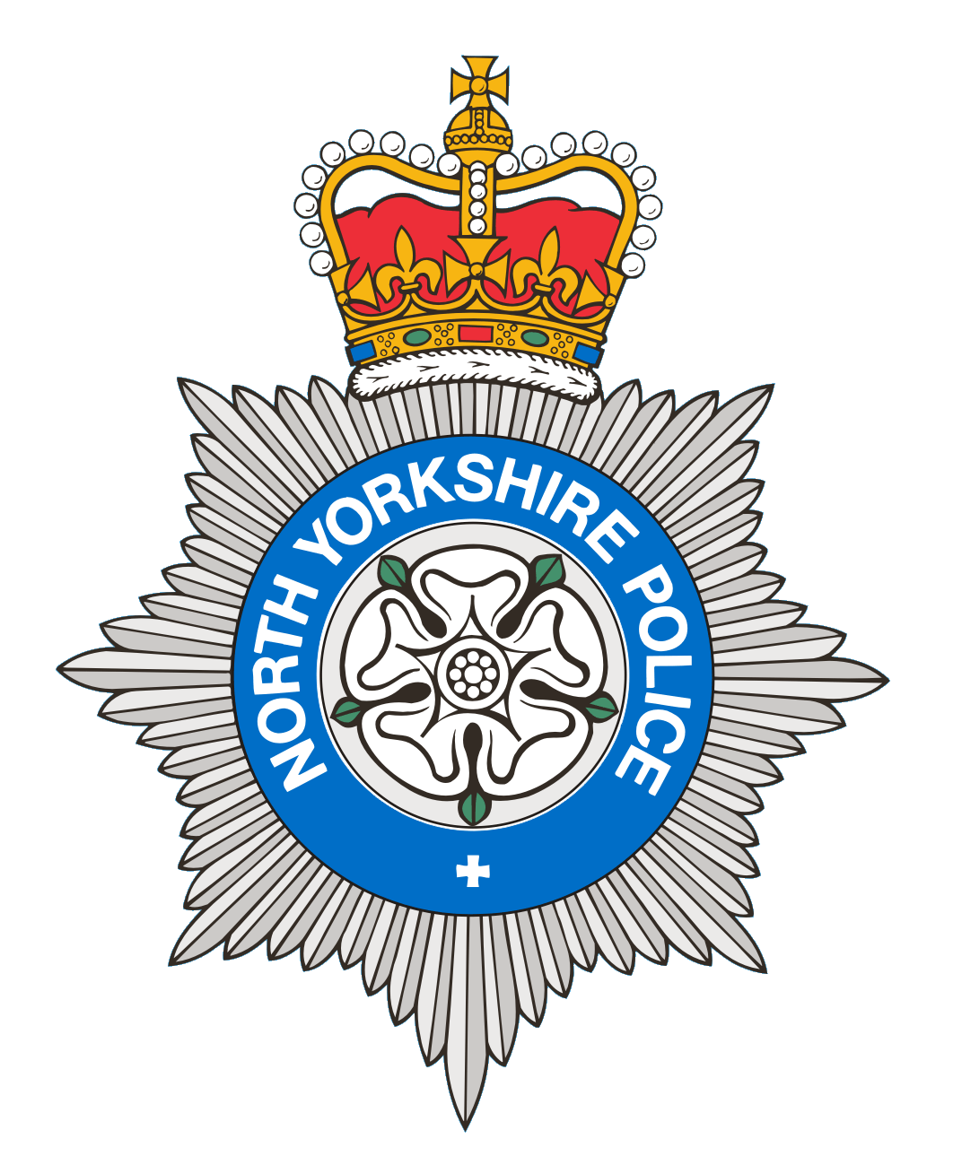
PCSO 3521 Diane Smith
Produced: 13th August 2025
Date of meeting- 19th August 2025

BROUGH WITH ST GILES
PARISH COUNCIL MEETING 19th August 2025
POLICE REPORT

17/06/2025 – 13/08/2025

Please note that under the police crime reporting system, all reports of criminal activity are recorded as crimes. However, if at a later date it is ascertained that no crime has been committed, this will not show on parish council report due to time delay.

Crimes = 11
2 Reports of Stalking/harassment, 4 Reports of Crime Violence that were domestic related, 2 Reports of Criminal Damage, 1 was damaged caused to street lighting, 1 regarding suspected damage to a caravan. 3 Reports of theft, 1 was related to theft of a pedal cycle which was recovered and returned to owner, 1 report of sextortion, 1 report of theft of fuel.
Reported crime for the same period last year = 3

Anti-Social Behaviour = 2
1 ASB Nuisance – 1 Report of noisy youths, officer attended but youths had gone. 1 ASB Personal – Report of a child receiving malicious messages.
Reports of ASB for the same period last year =10

OTHER REPORTS includes Highway Disruption and RTC’s

1 Administration – 1 Report of information passed to NYP.

4 Road Related Incidents - 1 report of possible drink driver. 1 vehicle seized by NYP for no insurance. 1 Report of person travelling in the boot of a car, no further sightings. 1 Report of sighting of 2 young males on a moped riding on the footpath, no further sightings.
Other reports for the same period last year= 18

Personal/Safety/Warning Incidents = 6

2 Reports of concern - 2 Reports for a male who was given support and advice.

1 Reports of Suspicious behaviour – 1 Report of a vehicle acting suspiciously.

3 Reports of Domestic Incidents.
Other reports for the same period last year =17

Community Messaging
North Yorkshire Community Messaging allows members of the public to register to receive alerts, crime notifications and community news from organisations. It is a way of maintaining contact with Neighbourhood Watch and Rural Watch groups. Neighbourhood & Rural Watch have their own database within community messaging for their members.

​You can sign up to receive alerts as a member of the public here:
https://www.northyorkshirecommunitymessaging.co.uk/

If you wish to speak to your local Neighbourhood PCSO you can send an e-mail to PCSO3521 Diane Smith diane.smith@northyorkshire.police.uk phone 101, choose option 2, and follow the prompts.

